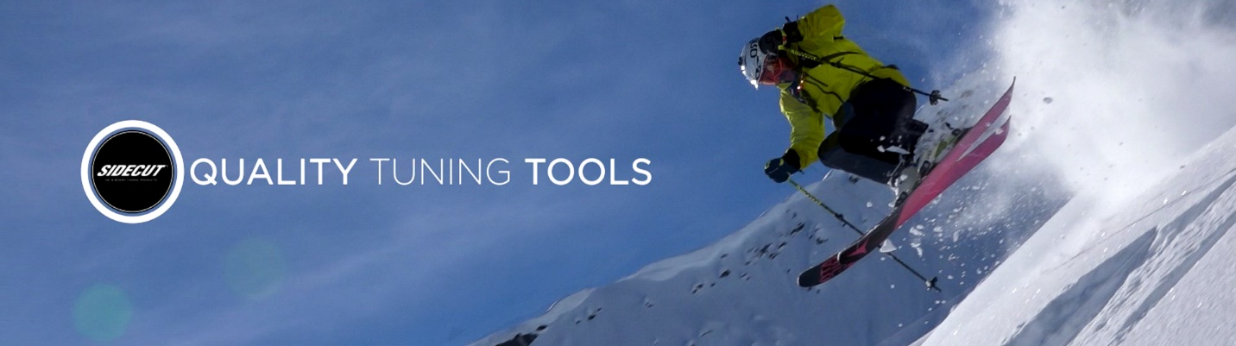
2021 WORKSHOP DISCOUNT PROGRAM
As a ski club member you’ll receive a discount on all items available on www.sidecut.com
Step 1: Go to www.sidecut.com and click Workshop Signup on the bottom of the homepage.
Step 2: Enter the Promo Code: JS3 and click the verify button.
Step 3: Create your personal account by entering your details.
Step 4: Sign in and you’re ready to shop. Be sure your discount is displayed. Note: if you already have a SIDECUT account email sidecut@sidecut.com to have this discount activated.
Click here: https://youtu.be/PRxtaubkahE for video instructions on how to create your personal account.
***The Workshop discount cannot be combined with other discounts or free shipping promotions. Sidecut reserves itself all rights to cancel or refuse any orders that do not meet the program requirements.***
Sidecut designs the highest quality tools & provides professional free tuning videos and workshops enabling skiers & snowboarders to reach their maximum potential.
Learn to Tune this season! Click the link to get motivated: https://youtu.be/S-dMBVjxofs
